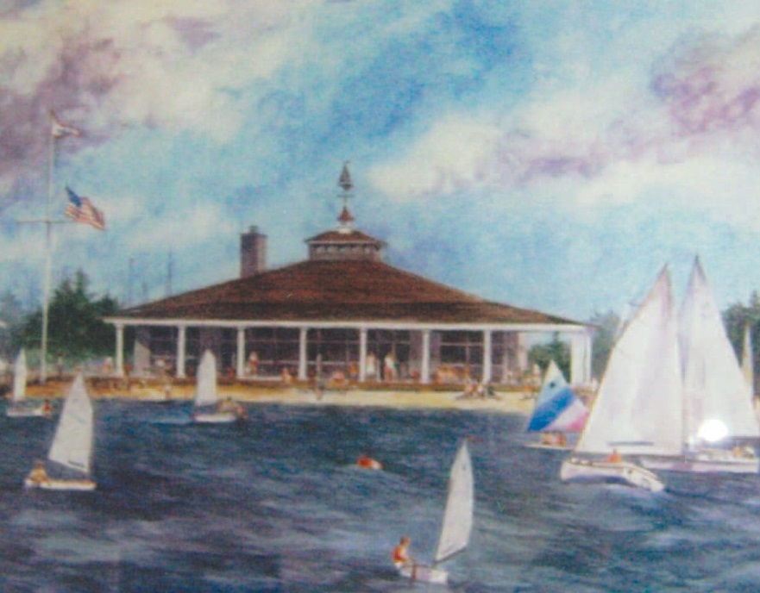

NORMANDY BEACH YACHT CLUB
NORMANDY BEACH, NEW JERSEY

MEMBERS 2024

NORMANDY BEACH YACHT CLUB
PO Box 726, 236 South Ct., Normandy Beach, NJ 08739 732-793-0152
Web Site - nbycnj.com

2024 OFFICERS

COMMODORE
Mark Connell

VICE COMMODORE
Wayne McCaughey

REAR COMMODORE
Robert Brautigan

FLEET CAPTAIN Rick Lill

This book is for the distribution to current NBYC members only.
The information contained within this book is the property of the Board of Trustees.

GENERAL MANAGER STEVE MACPEEK 732-948-3169

NORMANDY BEACH YACHT CLUB
BOARD OF DIRECTORS 2024

FOUR YEAR DIRECTORS

Brigid Smircich, Chairman
Dan Kane, Vice Chairman
Mark Connell, Commodore
Wayne McCaughey, Vice Commodore

Pamela Waldron Two Year Director/Trustee
Rick Kilcoyne Two Year Director/Trustee
Garrett Ferris Two Year Director/ Trustee
Robert Palmisano One Year Director/Trustee
Lynn Kirby One Year Director/Trustee

KAREN MAHER, Treasurer

KRISTEN GATES, Secretary

PAST COMMODORES

Richard Wasserman | 1946
George A. Ehrhardt | 1947-1953
Ray H. Isaacs | 1954-1955
F. F. Phillips | 1956
Burtis C. Ashmen | 1957
Dr. Wm. T. R. Cox | 1958
Albert C. Bertholon | 1959
Wilhelm B. Bronander, Jr. | 1960
William E. Whited | 1961
Clarence Maves | 1962
Clifford A. Warren | 1963
Herbert R. Angen | 1964
Joseph J. Abbott | 1965
David A. Karner | 1966
Charles G. Mortimer, Jr. | 1967
Robert L. Klass | 1968
Peter M. Grygotis | 1968
Frank P. Wilson | 1969
Ernest H. Pauli | 1970
John Chuhinko | 1971-1972
Edward Schwalje | 1973
Wilton Estes | 1974
Edward Dimon | 1975
John Kenny | 1976
Bruce A. Bertholon | 1977
Fredrick P. Collani | 1978
Arthur M. Harden | 1979
Richard M. Sayers | 1980
Joseph Faccone | 1981
Robert R. Schwartz | 1982
Charles Lynch | 1983
Arthur L. Snyder | 1984

Robert Cirillo | 1985-1986
Ernest Wayne Curry | 1987
William Du Rie | 1988
John Dorer | 1989
Russell Hewit | 1990-1991
James C. Hackett | 1991
Thomas Zusi | 1992
Kevin Dalton | 1993
Lawrence Reid | 1994
Fred Heine | 1995
Lawrence O’Hearn | 1996
Janet Keating | 1997
Ched Church | 1998
John Cranley III | 1999
Taugh Lynch | 2000
Robert Ceresi | 2001
David Hewit | 2002
Jack Ward | 2003
Peter Newman | 2004
James Moran | 2005
John Mahoney | 2006
Lori Hofstetter | 2007
Patrick Parisi | 2008
John Jago | 2009
Linda Graham | 2010-2011
Robert Scott | 2012
John Boyle | 2013
James Muller | 2014
Clark Convery | 2015
Janet S. Howard | 2016
Don Parseghian | 2017

Peter Schwartz 2018
Brendan Maher 2019
Jim Dunckley 2020
Chris Eler 2021
Brigid Moran Smircich 2022
Dan Kane 2023

THE HISTORY OF THE BRONANDER TROPHY

The Bronander Trophy was created in 1958 by Wilhelm Bronander when he was Vice Commodore of the club. As Vice Commodore Bill was very involved with the Junior Sailing Program and felt that there should be an award for the sailor who exhibited outstanding sportsmanship. In those early days the junior sailors raced every Wednesday and Sunday morning in Penguins.

In 1973 the club Directors felt that the criteria for awarding the Bronander Trophy should be changed to honor the club member who gave outstanding service over and above that which would be expected. Thus, beginning in 1973 and succeeding years, the trophy has been awarded to a club member for outstanding service to the Normandy Beach Yacht Club.

BRONANDER TROPHY RECIPIENTS

Edward Dimon, Jr. | 1959
No Award | 1960
Scott F. Wing | 1961
Susan A. Karner | 1962
John C. Mooney | 1963
Valerie H. Chuhinko | 1964
Gary S. Krueger | 1965
Alby Dill, Jr. | 1966
Holly I. Bronander | 1967
Penny Warter | 1968
Lorraine Pauli | 1969
Carol Kenny | 1970
Wendy Thrower | 1971
Wilt Estes | 1972
Cathy Cipolla | 1973
Fred Collani | 1974
Ted LaPier | 1975
Art Snyder | 1976
Virginia Thrower | 1977
Edward J. Dimon | 1978
Bruce Bertholon | 1979
Dorothy J. Walsh 1980
Rosemarie P. Faccone 1981
Anthony R. Conte 1982
Ted LaPier 1983
Virginia Thrower 1984
Arthur M. Harden 1985
Leonia Reilly 1986
Kevin Healy 1987
Marcia W. DuRie 1988
William W. DuRie 1989
Francis F. Phillips 1990
O. H. Hewitt III 1991
Robert J. Cirillo 1992
Steve Foster 1993
Joseph F. Faccone, Jr. 1994
Charles F. Lynch 1995
Richard M. Sayers 1996
Virginia Thrower 1997
Janey Rosenberg 1998
Wendy and Wayne Curry 1999
Virginia and Peter Newman 2000
Emma Lou Sayers 2001
Linda Bronander Graham 2002
Carole Ceresi 2003
Donald E. Peters 2004
Steve Foster 2005
Carol Hewit 2006
Art Snyder 2007
Vincent Turturiello 2008
Betsy Foster 2009
Donna Rothman 2010
Jeanne Pauly 2011
John Jago 2012
Robert Scott 2013
Steve MacPeek 2014
Janey Rosenberg 2015
Anne and Mike Lackland 2016
Steve MacPeek 2017
Rick Lill & Matt Monagas 2018
Lynn Legg & Betty Resch 2019
Amy Schwartz 2020
Karen Maher 2021
Jack Ward 2022
Ceci Muller, Caroline Maher, & Anna Schwartz 2023

NORMANDY BEACH YACHT CLUB

2024 COMMITTEE MEMBERS

Budget Committee
Karen Maher - Chair
Brigid Smircich
Dan Kane
Mark Connell
Wayne McCaughey
Rick Lill
Rob Brautigan

Membership Committee
Maria Kreyer- Chair
Jeanne Pauley
Martha Kirby
Wayne McCaughey
Sue Egan-Carson
Tom Flynn
Brigid Smircich

Nominating Committee
Pamela Waldron - Chair
Ryan Egan
Joe Ferris
Joe Giordano
Jenny Schwartz

Boat Committee
Rick Lill - Chair
Bob Ceresi
Bob Cirillo
Mark Connell
Alan Rothman
Ryan Jago

Ships Store
Betty Lender Resch
Lynn Lender Legg
Rick Kilcoyne

Social Committee
Mark Connell - Chair
Carolyn Dunkley
Ryan Jago
Brendan Maher
Cathy Wronowski
Dan Jago
Cindy Diaz
Bob Ceresi
Steve MacPeek

NORMANDY BEACH YACHT CLUB

2024 COMMITTEE MEMBERS

Race Committee
Wayne McCaughey
- Chair
Janet Howard- BBYRA Rep
John Armstrong
Dave Carver
Mark Connell
Jim Hackett
Scott Hengst
Dave Hewit
Helen Lund
Marty Lund
Larry Reid
Janey Rosenberg
Peter Schwartz
Peter Stagaard
John Stewart
Brian Wnorowski

Junior Sailing Committee
Wayne McCaughey- Chair
Amy Schwartz - Junior Sailing Coordinator
Scott Hengst
Robyn Hryniw
Ginny Newman
Christine Readlinger
Ryan Stagaard
Peter Schwartz

Communications Committee
Bob Ceresi - Chair
Carole Ceresi
Brendan Maher - Website
Muffin Muller - Photos

